Graduate Research Plan Statement
More than 80% of global trade was transported by sea in 2024. That same year the US reported nearly 4,000 boating accidents and over 500 deaths, with more than 50% of these accidents caused by object collisions. Even small gains in detection performance could prevent many of these collisions.
Modern camera-based perception performs well in clear daytime scenes because models are trained on huge, labeled photo collections, but these systems degrade at night, in heavy weather, and in chaotic littoral environments. Active radar penetrates fog and darkness and provides reliable range/bearing, yet radar lacks image detail and can either miss small targets or confuse sea clutter for objects (Fig. 1). [1][2]
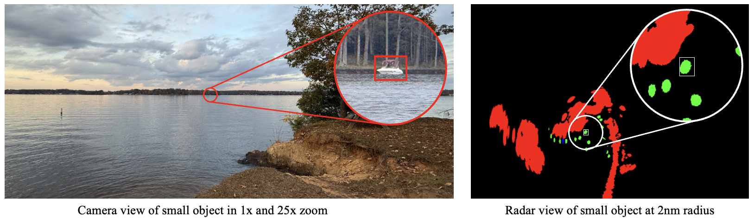
Figure 1. Small boat is nearly invisible in the camera view but appears clearly in the radar return at 2 nm.
Machine learning promises to bridge these gaps, but scaling purely supervised approaches is infeasible for maritime data because manual labeling at sea is slow, costly, and dangerous. [3] Our approach combines (a) radar–camera fusion so each sensor can validate and correct the other, and (b) physics-aware self-training and auto-labeling that learn from large unlabeled streams with minimal human verification. [1][3]
I propose a physics-aware, self-training detection system that fuses radar and camera imagery, filters provisional labels with radar-informed checks, and trains compact models for tiny-target detection on affordable edge hardware (Fig. 2).
Figure 2. End-to-end obstacle detection pipeline combining radar, camera, GPS, and self-learning fusion.
Intellectual Merit
Small objects are missed because they occupy few pixels, fall under sensor quantization/noise, and are masked by sea clutter [2]. Current fixes — costly dense labeling, oversized supervised models, and post-hoc tracking — don’t scale for maritime data and often drift under noisy conditions [3].
I combine three innovations to address these limits: (1) transformer-style backbones pre-trained on unlabeled radar via masked reconstruction to learn robust radar features; (2) physics-aware radar–camera fusion that enforces geometric and feature consistency so each sensor can veto or confirm tentative labels [1]; and (3) a vetted auto-labeling loop that uses radar checks and confidence-weighted curation to reduce human labeling dramatically [3].
Success is measured with AP_small, recall at low false-alarm rates, label-efficiency curves, and edge latency tradeoffs. My hypothesis is that radar-guided filtering plus multi-gain HDR cues raises small-object performance while reducing required human labels.
Figure 3. Radar annotation strategies No assistance vs. physics-informed auto-labelling vs. ML labelling.
Approach
I will use USC computing and lab equipment and a growing team to scale data collection and model development. The dataset contains about 200k radar frames and will be expanded to 2M frames.
Aim 1: Radar-only self-learning. Learn useful representations directly from raw radar without labels and then train a small detector using a very small set of human labeled examples. Test whether this approach reduces the need for manual labeling.
Aim 2: Radar & camera fusion models. Combine radar and camera data so each sensor helps confirm the other. Use simple physics-based checks to keep labels accurate and focus the model on small objects.
Aim 3: Deployment and dataset production. Make the best models run efficiently on small, low power computers and use those models to label more data automatically. Humans will check a small fraction of the labelled frames to keep quality high and measure run time and power use on representative devices.
Broader Impacts
There is no widely used open benchmark for small-object maritime detection on low-cost radar + camera sensors; existing public datasets are small or use high-end hardware. This project will release a cleaned, privacy-conscious dataset, evaluation scripts, and a public benchmark to lower barriers for researchers and agencies. The auto-labeling loop will make large-scale dataset creation practical and reduce annotation cost/time, accelerating development of safety-critical maritime perception (Fig. 4).
Figure 4. Broader Impacts network of proposed work in Physics-Aware Fusion and Auto-Labeling
References:
[1] Shi, K., et. al. Radar and Camera Fusion for Object Detection and Tracking: A Comprehensive Survey. arXiv
[2] Navya, R., et. al. A Systematic Survey on Radar Target Detection Techniques in Sea Clutter Background. In Smart Computing Techniques and Applications, Springer
[3] Shehzadi, T., et. al. Semi-Supervised Object Detection: A Survey on Progress from CNN to Transformer. arXiv

